C3C James Rushing
OR 310 T5
Captain Miller
15 March 2013
MADM Executive Summary

To finalize the Outdoor Recreation’s vehicle purchase, Multi-Attribute Decision Making was used. The attributes that were analyzed include transporting customers to and from the mountains, hauling merchandise, and towing trailers and boats. Upon using MADM analysis and analyzing eight vehicles, the Outdoor Rec center should purchase either a Ford F-250 Super Duty or a Dodge Ram 1500 with a 5.7 liter Hemi engine (both are American made as requested).
In order to use multi-attribute decision making, the ORC’s requirements were first considered, followed by inputs of various others. Each attribute was then taken into consideration and formed into 3 main goals, where the goals were then broken down into objectives and attributes. The attributes were then weighted and compared in a swing weight matrix (Appendix 1). Next the attributes of each vehicle were ranked from least to most satisfactory (0-10) and then put into an algorithm. The algorithm took the data for each attribute of the nine 2013 model alternatives (one was an ‘ideal’ car) and was run (Appendix 2). The measured values were then multiplied by their swing weights and summed. The sums of each were put into a stacked bar chart (Appendix 3). Furthermore, the five year cost of ownership was added to the purchasing cost, giving a total cost of ownership. The graphic below shows the total cost of ownership plotted against the value:

Lastly, the sensitivity of the decision was tested, which had no effect on the final decision (Appendix 4). A Dodge Ram 1500 should be purchased because it has a cheaper total cost of ownership, has the 2nd highest safety rating, tows the 2nd most, has the 3rd most storage, has 4x4, and saves $14,693 over five years without sacrificing much overall value when compared to the F-250. When looking at purchasing a vehicle, the Ford Flex should not have been considered as an alternative because it doesn’t meet the ORC’s minimum for towing weight (only 4500). In addition, it has inferior ratings in storage, torque, HP, and is near the bottom for powertrain warranty length. As far as attributes are concerned, the Dodge Ram outranks the Ford Flex in all categories except seating capacity and miles per gallon, showing the Flex’s clear inferiority.
Appendix 1 – Executive Summary
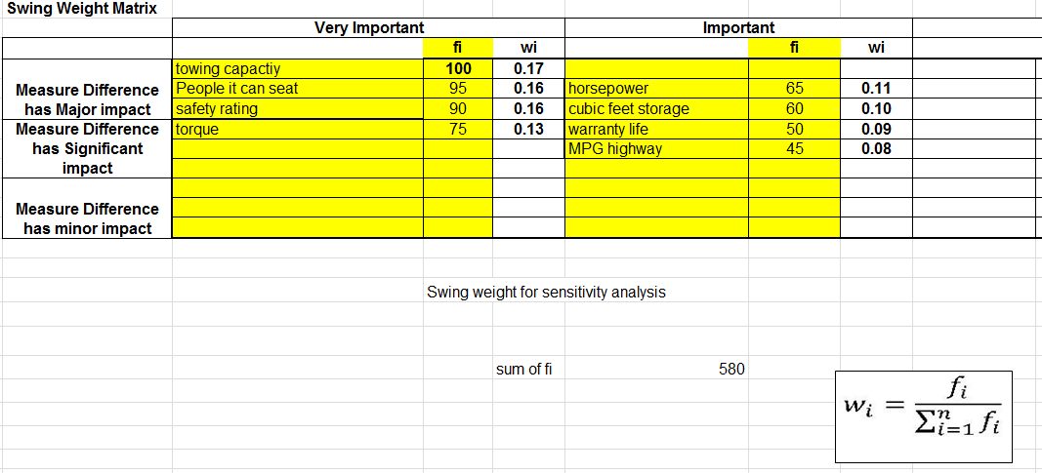
Above is the swing weight matrix which weights each attribute. To get this, the value for the attribute is divided by the overall sum, which becomes wi. The weight then goes to the algorithm shown in appendix 2. High priority attributes (towing) got higher weights than low priority attributes (MPG).

Appendix 2 – Executive Summary

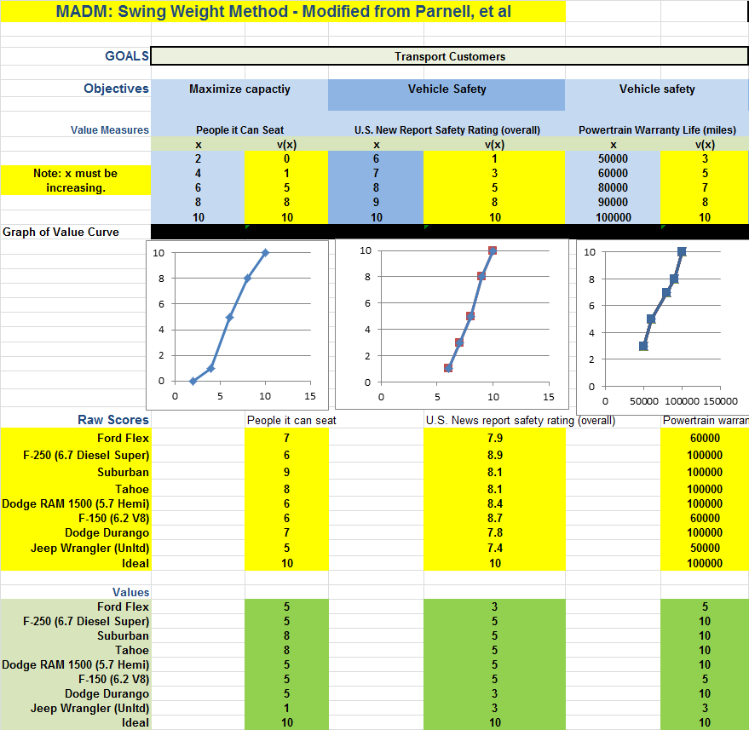
Above is one piece of the algorithm which works top to bottom, starting with the goals. The goals were then broken into objectives. Below the scores are global weightings and swing weights. The swing weights were then multiplied by the attribute score and summed for each alternative.

Appendix 3 – Executive Summary
Above is a graph of the total normalized value of each vehicle. These were summed by using the algorithm and adding the values of each of the three goals of performing in adverse conditions, hauling gear, and hauling customers. According to this, the F-250 is the best overall value and the Jeep Wrangler is the least. The Ford Flex was the second worst.

Appendix 4 – Executive Summary

Above is a sensitivity analysis performed on the towing capacity. Although our alternatives changed a little bit, the overall choice of a Ford F-250 or Dodge Ram 1500 did not change as the individual swing weight of towing increased or decrease. The overall choice was not sensitive at all.

Works Cited

Best Cars. US News & Rankings, 2013. Web. 11 Mar. 2013. <http://usnews.rankingsandreviews.com/cars-trucks/>
Motor Trend. 2013. Web. 11 Mar. 2013. http://www.motortrend.com/

Documentation: No help was received from other cadets.

